Q No.4 Write an HTML code to create an institute website, department website, and tutorial website for a specific subject ?
<!DOCTYPE html>
<html>
<head>
<title>Institute Website</title>
</head>
<body>
<h1>KIET Group of Institutions</h1>
<h2>Welcome to Our Institute</h2>
<p>
KIET Group of Institutions is an educational institute providing quality education and opportunities to students.
</p>
<h3>Courses Offered</h3>
<ul>
<li>B.Tech</li>
<li>M.Tech</li>
<li>MBA</li>
<li>MCA</li>
</ul>
<h3>Facilities</h3>
<ol>
<li>Library</li>
<li>Computer Labs</li>
<li>Sports Facilities</li>
<li>Hostel</li>
</ol>
<p><b>Contact:</b>
info@kiet.edu</p>

</body>
</html>

<!DOCTYPE html>
<html>
<head>
<title>Department Website</title>
</head>
<body>

<h1>Department of Computer Science And Information Technology</h1>
<h2>Welcome to the CSIT Department</h2>

<p>
The Department of Computer Science and Engineering provides
students with knowledge of programming, computer systems,
software development and emerging technologies.
</p>

<h3>Faculty Members</h3>
<ul>
<li>Dr. Abhinav Juneja - Professor</li>
<li>Dr. Harsh Khatter - Dean</li>
<li>Dr. Ankur Garg - Program Head</li>
</ul>

<h3>Subjects</h3>
<ol>
<li>Programming in C++</li>
<li>Digital Logic And Design</li>
<li>Design and Realization</li>
<li>Calculus For Engineers</li>
<li>Engineering Physics</li>
<li>Web Designing and Cloud Foundations</li>
</ol>

<p><b>Email:</b> CSIT@kiet.edu</p>

</body>
</html>
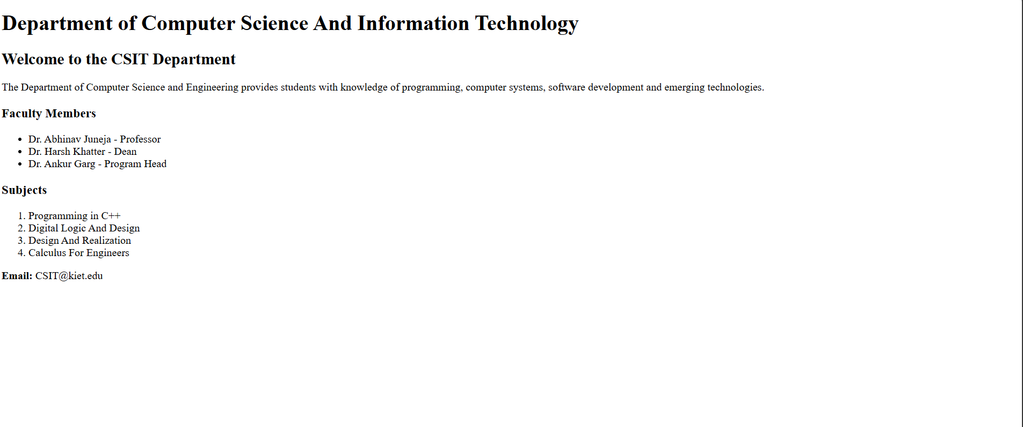
<!DOCTYPE html>
<html>
<head>
<title>C++ Programming Tutorial</title>
</head>
<body>

<h1>C++ Programming Tutorial</h1>

<h2>Introduction</h2>
<p>
C++ is a general-purpose programming language used to develop
software, games, applications and system programs.
</p>

<h2>Topics Covered</h2>
<ol>
<li>Introduction to C++</li>
<li>Variables and Data Types</li>
<li>Operators</li>
<li>Conditional Statements</li>
<li>Loops</li>
<li>Arrays</li>
<li>Functions</li>
</ol>

<h2>Conclusion</h2>
<p>
By learning these topics, students can develop a strong
foundation in C++ programming.
</p>

</body>
</html>
